| **Course: CSE 462 - Network Analysis and Design**  **LAB 2 – Switch Networks** |
| --- |

| **Group ID** | *Group 1* |
| --- | --- |
| **Student Name** | **Ngô Quang Khiêm,**  **Hà Quang Minh,**  **Lê Quốc Khánh** |
| **Final Score** |  |

**Lab Exercise Submission**

Students are responsible for submitting the final report by the stated deadline for full marks. Late submissions will NOT be accepted.

**Objective:** This lab is to guide students how to build switch networks.

**NOTE:** *Students should read the guideline carefully before conducting Lab experiments.*

**🙡 - Good luck - 🙣**

# TASK 1 – HOW TO RESET SWITCH

Switch>**enable**

Switch#**delete flash:vlan.dat**

Delete filename [vlan.dat]?[**Enter**]

Delete flash:vlan.dat? [confirm] [**Enter**]

If there was no VLAN file, this message is displayed.

%Error deleting flash:vlan.dat (No such file or directory)

Switch#**erase startup-config**

Erasing the nvram filesystem will remove all files! Continue? [confirm] **Enter**

Erase of nvram: complete

**Use the reload command to reboot the switch:**

Switch#**reload**

System configuration has been modified. Save? [yes/no]: **n**

Proceed with reload? [confirm] [**Enter**]

Reload requested by console.

Would you like to enter the initial configuration dialog? [yes/no]: **n**

Press RETURN to get started! [**Enter**]

Switch1

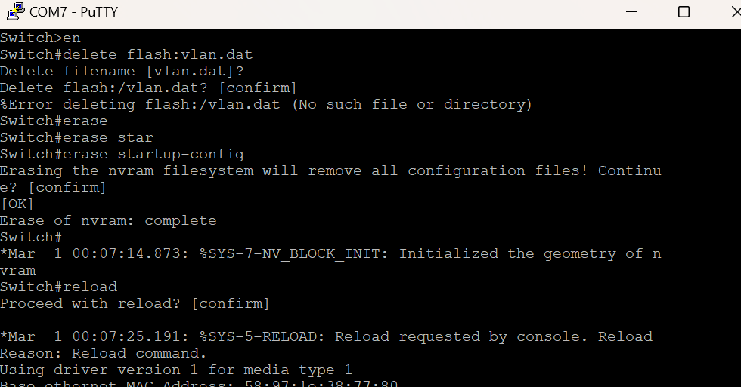

Switch2

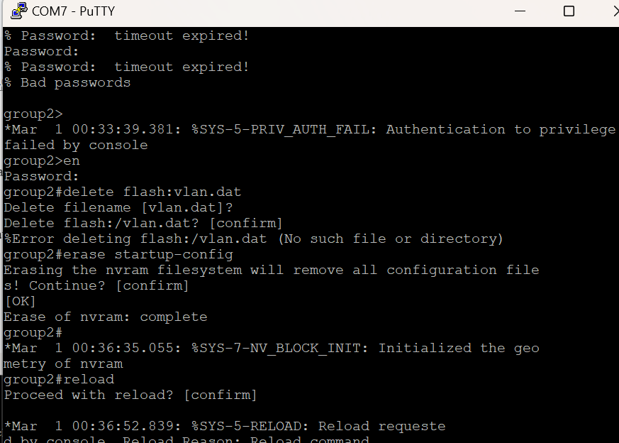

**Result**

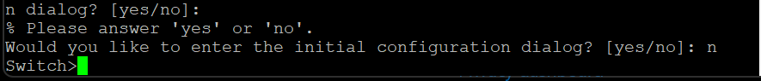

# TASK 2 – BASIC SWITCH NETWORK

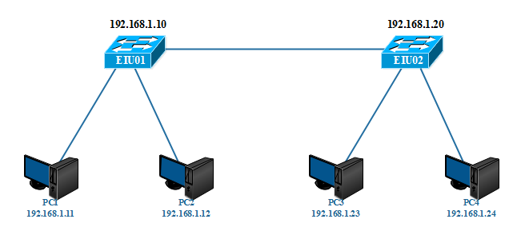

*Figure 2.1. Basic switch network diagram*

**Make device connections according to the above model.**

***Note****: Delete old configuration information existing in the devices before proceeding*

**Step 1: Make connections according to the diagram and configure basic parameters for the Switch (See lab 1)**

- Set **hostname, banner**

- Set enable pass as **“eiu@123”**

- Configure and set password for **telnet** sessions, password is **“cisco”**

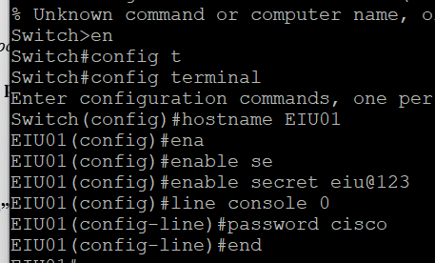

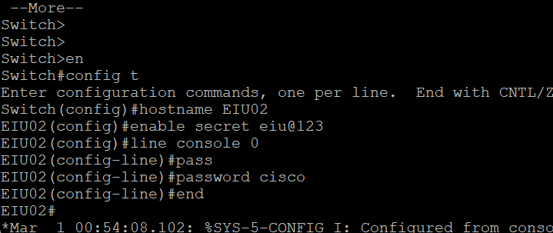

**Step 2: Configure IP for switches and PCs**

**PC1: 192.168.10.11**

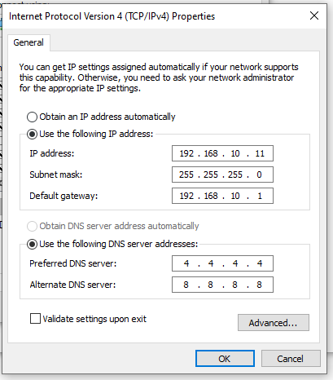

**PC2: 192.168.10.12**

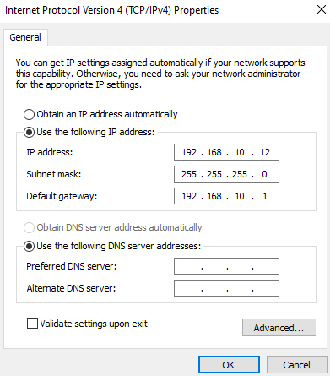

**PC3: 192.168.10.23**

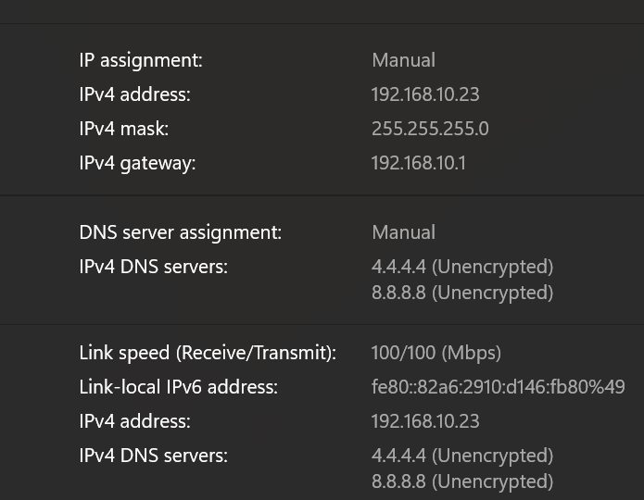

To configure the IP for the Switch, **you must go to interface vlan1**, and the IP on the switch only is for the management purpose.

EIU01(config)#**interface vlan 1**

EIU01(config-if)#**ip address 192.168.1.10 255.255.255.0**

EIU01(config-if)#**no shutdown**

EIU01(config-if)#**exit**

EIU01(config)#**ip default-gateway 192.168.1.1**

EIU01#**copy running-config startup-config**

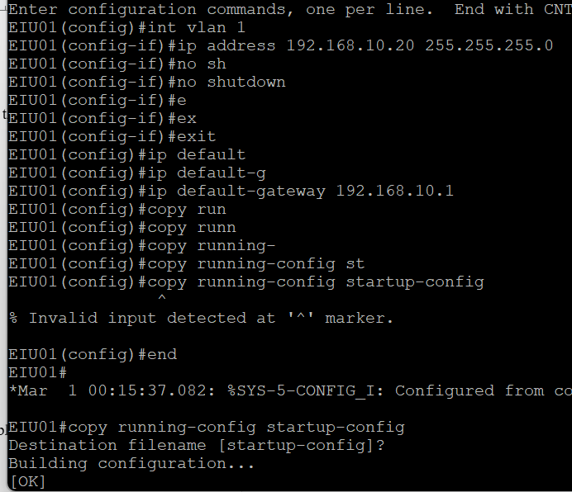

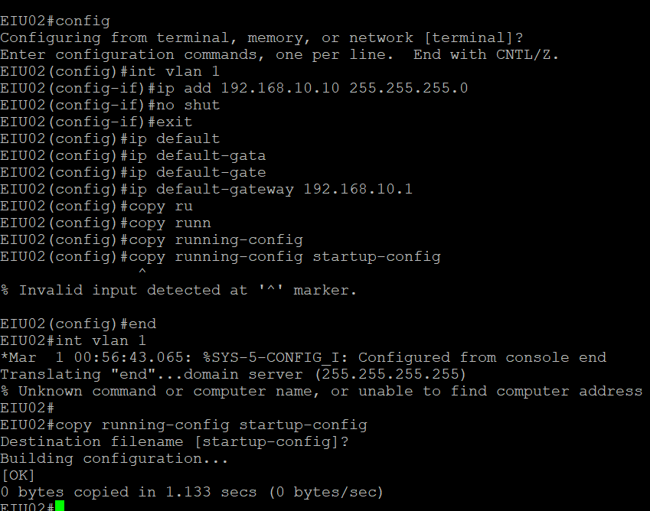

***NOTE: Do the same on the remaining devices***

**Step 3: Check configuration information:**

EIU01#**show running-config**

EIU01#**show vlan**

EIU01#**show mac-address-table**

**SWITCH 1:**

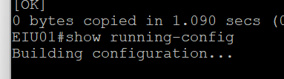

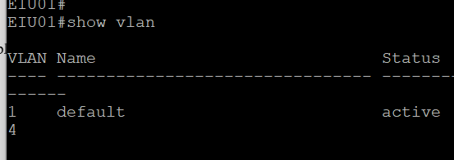

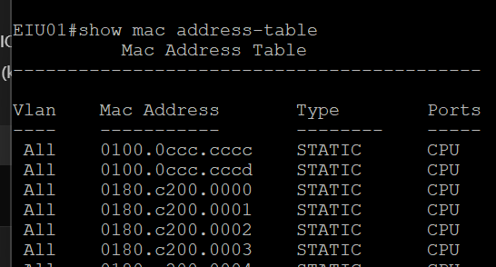

**SWITCH 2:**

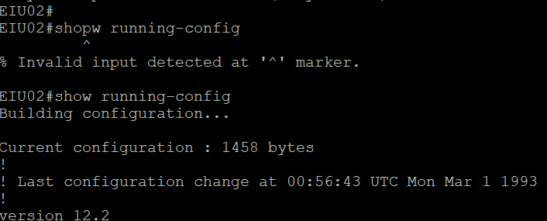

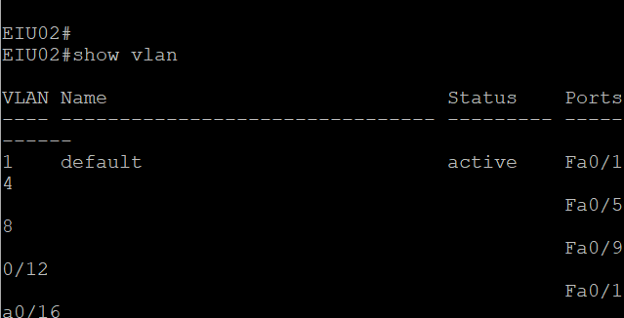

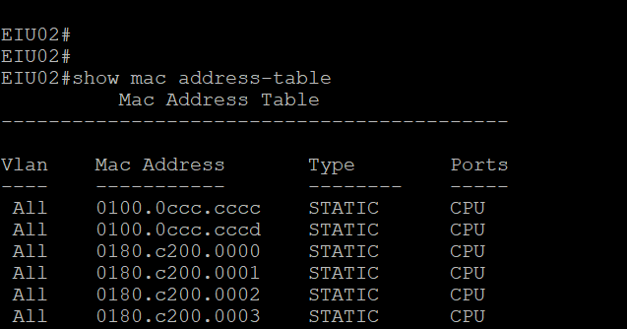

Execute the command to **delete old information** in the MAC address table:

EIU01#**clear mac-address-table**

Then **review the information** in the MAC address table:

EIU01#**show mac-address-table**

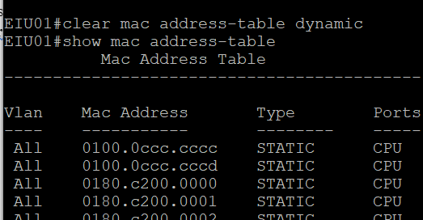

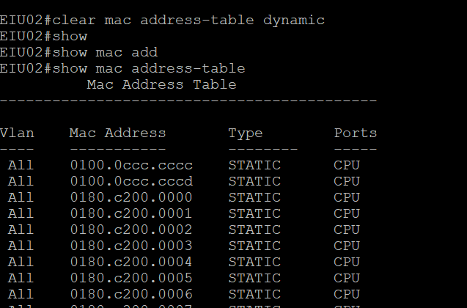

**Step 4: Check the connection between PCs and between PC and Switch**

1. Use the **Ping** command from PC1 to the switch, and other PCs in the model.
2. Observe the **Ping** process. If it **fails**, you must **check configuration again.**
3. From PC1, **telnet** to the Switches in the model.

PC3-PC1&PC2

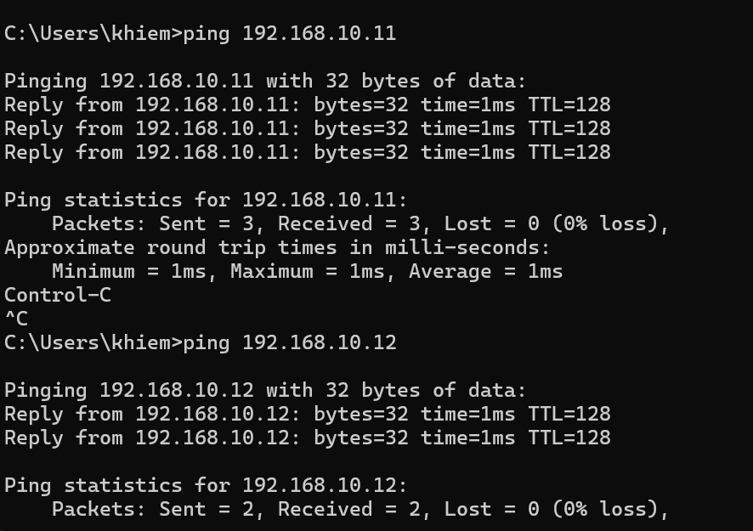

PC3-SWITCH 1

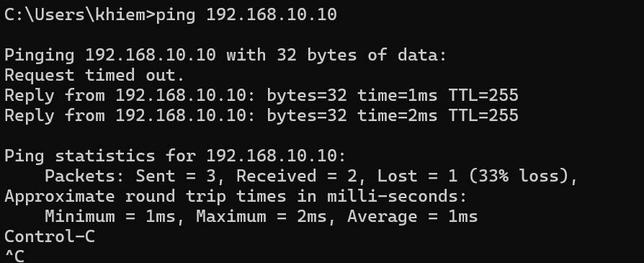

PC3-SWITCH 2

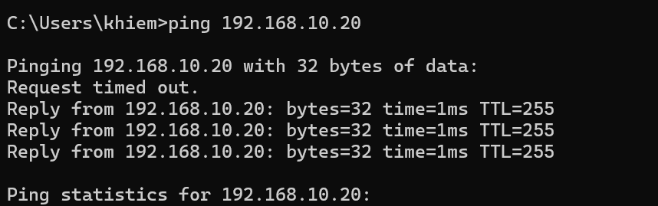

TELNET

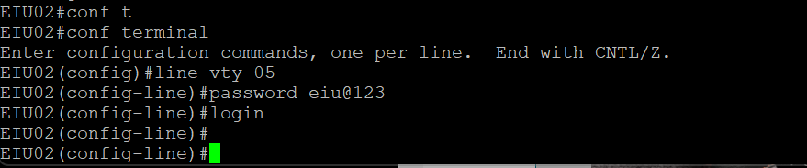

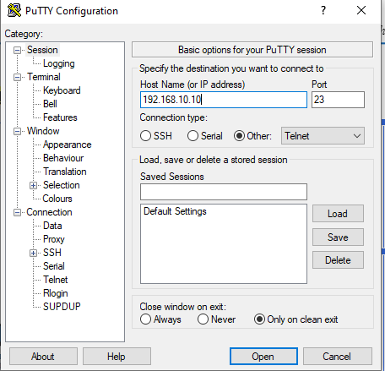

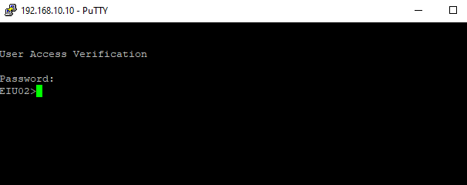

# TASK 3 – EXTENTED SWITCH NETWORK

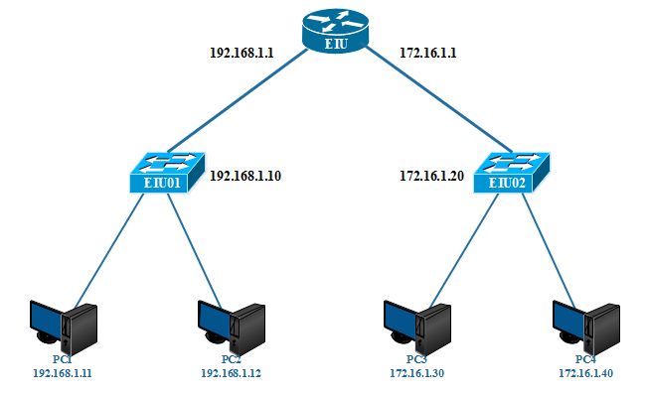

*Figure 2.2. Expanded switch network diagram.*

**Step 1: Make connections according to the diagram and configure basic parameters for the Router (See lab 1)**

- Set **hostname, banner**

- Set enable pass as **“eiu@123”**

- Configure and set password for **telnet** sessions, password is **“cisco”**

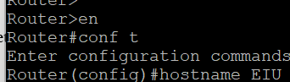

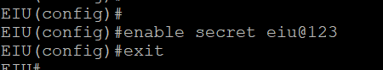

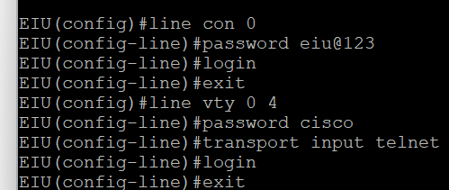

**Step 2: Configure IP for switches, routers and PCs**

In the above model, can it **work without a Router device**? What is the role of the Router in the above model?

***Answer:***

**PC3:**

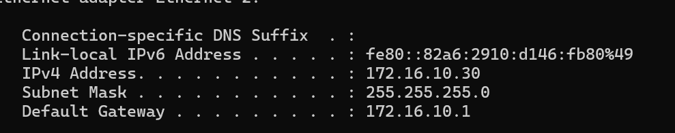

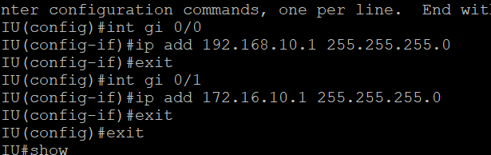

**Step 3: Check configuration information:**

#**show running-config**

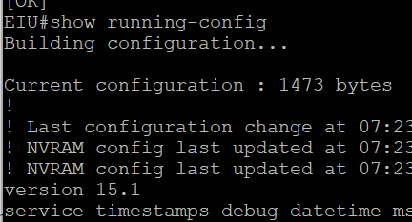

#**show vlan**

#**show ip route**

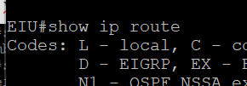

**#show ip interface brief**

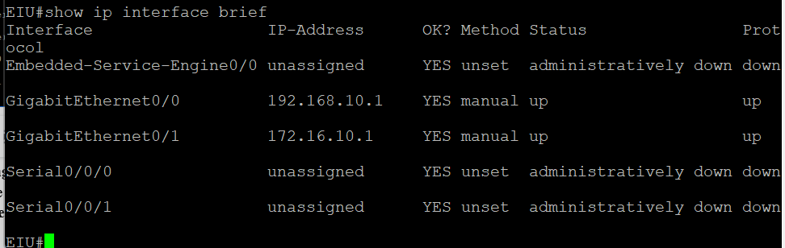

**Step 4: Check the connection between PCs, Switch and Router**

1. Use the **Ping** command from PC1 to the switch, and other PCs in the model.
2. Observe the **Ping** process. If it **fails**, you must **check again.**
3. From PC, **telnet** to the Switches in the model.

PING PC2 -> ROUTER AND SWITCH2

# 

TELNET

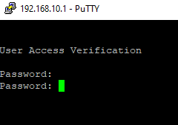

# TASK 4 – VLAN and TRUNKING

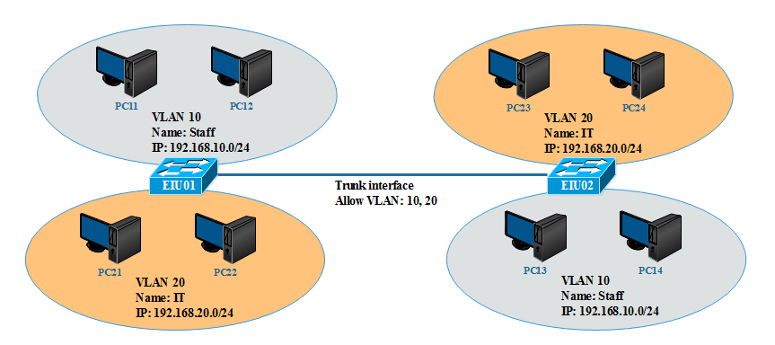

*Figure 2.3. Switch network diagram with VLAN and trunking*

* + - **VLAN 10: port 4, 5, 6**
    - **VLAN 20: port 7, 8, 9**
    - **Trunk: port 15**

**Step 1: Make connections according to the diagram and configure basic parameters for the Switch (See lab 1)**

* + - Set **hostname, banner**
    - Set enable pass as **“eiu@123”**
    - Configure and set password for **telnet** sessions, password is **“cisco”**

**Step 2: Assign IP addresses to PCs Example PC11:**

- *IP address*: 192.168.10.11

- *Subnet mask*: 255.255.255.0

***Do the appropriate configuration for other PCs***

* ***Vlan 10: PC1***

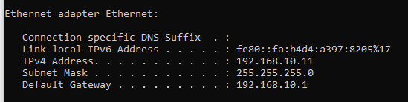

* ***Vlan 20: PC2***

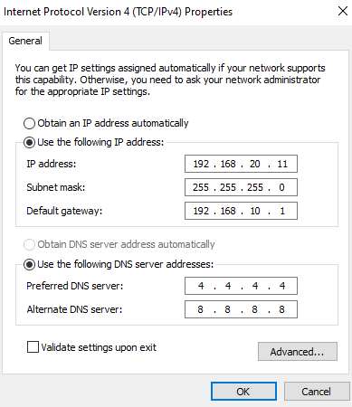

**pc3 (vlan 10):**

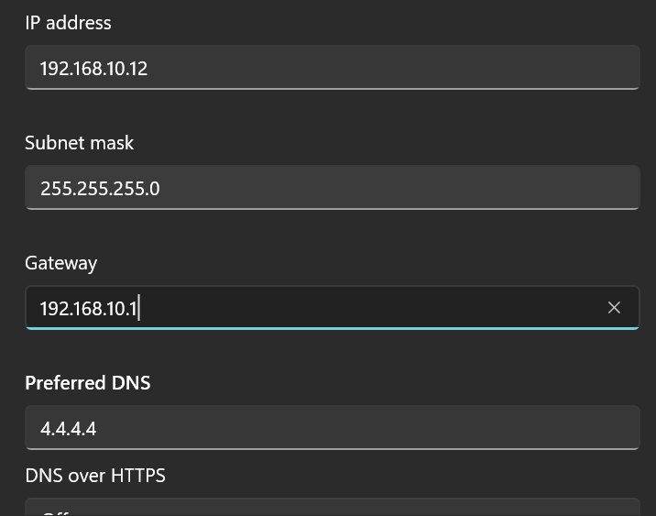

**Step 3: Create VLANs on SWITCHs**

**Switch EIU01**

EIU01#**show vlan**

EIU01(config)#**vlan 10**

EIU01(config-vlan)#**name Staff**

EIU01(config)#**vlan 20**

EIU01(config-vlan)# **name IT**

EIU01#**show vlan**

***Do the same for switch EIU02***

**Step 4: Assign ports to VLANs**

**Switch EIU01:**

Assign ports Fa0/4, Fa0/5, Fa0/6 to VLAN 10

EIU01(config)#**interface fastethernet 0/4**

EIU01(config-if)#**switchport mode access**

EIU01(config-if)#**switchport access vlan 10**

EIU01(config-if)#**interface fastethernet 0/5**

EIU01(config-if)#**switchport mode access**

EIU01(config-if)#**switchport access vlan 10**

EIU01(config-if)#**interface fastethernet 0/6**

EIU01(config-if)#**switchport mode access**

EIU01(config-if)#**switchport access vlan 10**

***Do the same for VLAN 20 and on Switch EIU02***

EIU01#**show vlan**

EIU01#**show running-config**

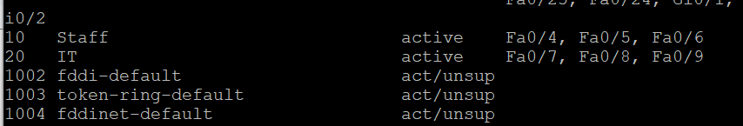

**Check the configuration information again:**

**Step 5: Check the connection between PCs**



1. Can PC11 ping PC12? Why? **Answer:**

Yes, because it’s in the same switch.

2. Can PC11 ping PC13? Why? **Answer:**

No, we have to turn on the trunk gate.

**Step 6: Create Trunk port with Encapsulation dot1q**

**Switch EIU01:**

EIU01(config)#**interface fastethernet 0/1**5

EIU01(config-if)#**switchport mode trunk**

EIU01(config-if)#**switchport trunk encapsulation dot1q**

EIU01(config-if)# **switchport trunk allowed vlan 10,12,13**

***Do the same with switch EIU02***

**Step 7: Check information on the Trunk interface with the following commands:**

**#show interface fastethernet 0/15 switchport**

**#show interface fastethernet 0/15**

**#show running-config**

**#show vlan**

**Step 8: Check the connection between PCs**

1. Can PC11 ping PC13? Why?

2. Can PC11 ping PC24? Why?

3. If **the PING was failed, suggest a solution to PING successfully**.

***Answer:***

[***https://mdungblog.wordpress.com/cau-hinh-telnet-ssh-cho-switch-cisco/***](https://mdungblog.wordpress.com/cau-hinh-telnet-ssh-cho-switch-cisco/)

**Task 4 : On Cisco Packet Tracer**

**VLAN AND TRUNKING**

* + - **VLAN 10: port 4, 5, 6**
    - **VLAN 20: port 7, 8, 9**
    - **Trunk: port 15**

**Step 1: Make connections according to the diagram and configure basic parameters for the Switch (See lab 1)**

* + - Set **hostname, banner**
    - Set enable pass as **“eiu@123”**
    - Configure and set password for **telnet** sessions, password is **“cisco”**

**Answer :**

**Switch EIU01**

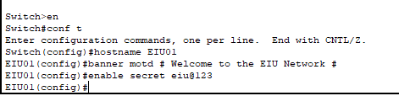

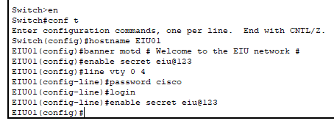

**Switch EIU02**

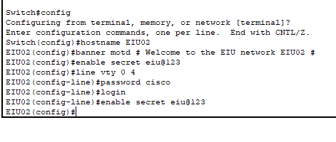

**Step 2: Assign IP addresses to PCs Example PC11:**

- *IP address*: 192.168.10.11

- *Subnet mask*: 255.255.255.0

***Do the appropriate configuration for other PCs***

**PC11 :   
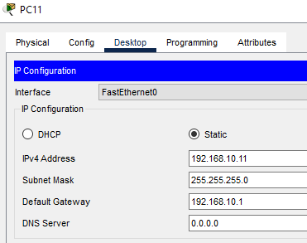**

**PC12**

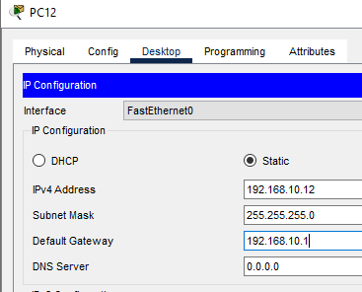

**PC13**

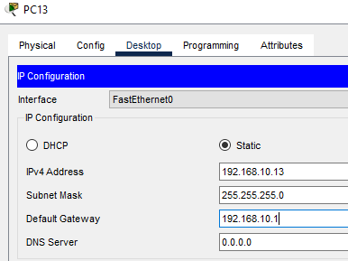

**PC14**

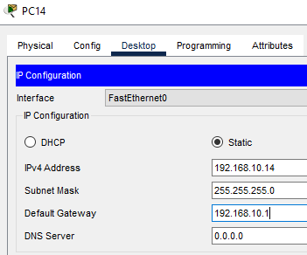

**PC21**

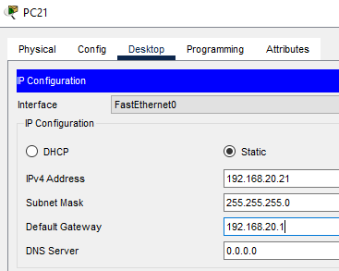

**PC22**

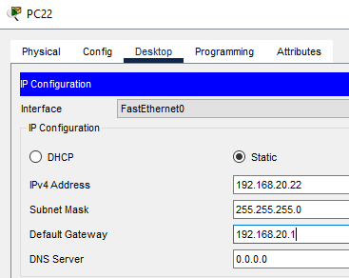

**PC23**

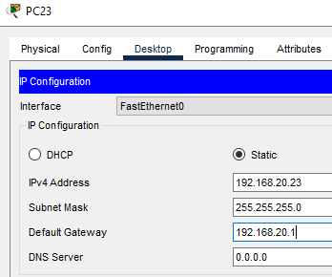

**PC24**

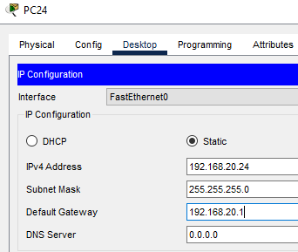

**Step 3 : Create Vlans on Switchs**

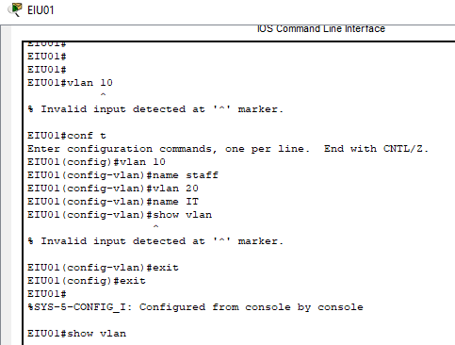

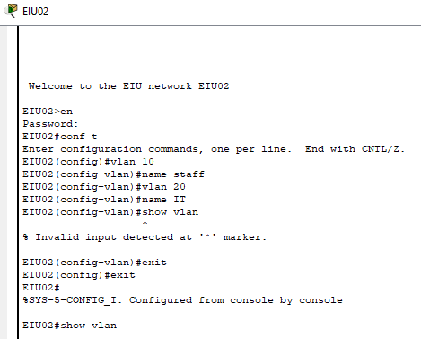

**Step 4: Assign ports to VLANs**

**Switch EIU01:**

Assign ports Fa0/4, Fa0/5, Fa0/6 to VLAN 10

EIU01(config)#**interface fastethernet 0/4**

EIU01(config-if)#**switchport mode access**

EIU01(config-if)#**switchport access vlan 10**

EIU01(config-if)#**interface fastethernet 0/5**

EIU01(config-if)#**switchport mode access**

EIU01(config-if)#**switchport access vlan 10**

EIU01(config-if)#**interface fastethernet 0/6**

EIU01(config-if)#**switchport mode access**

EIU01(config-if)#**switchport access vlan 10**

***Do the same for VLAN 20 and on Switch EIU02***

EIU01#**show vlan**

EIU01#**show running-config**

**EIU01**

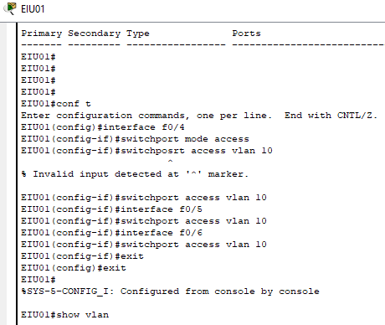

**EIU02**

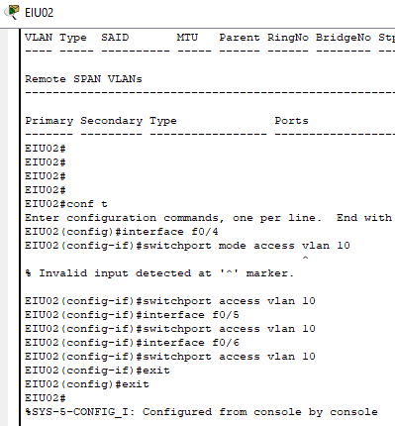

**Làm cho Vlan 20**

**EIU01**

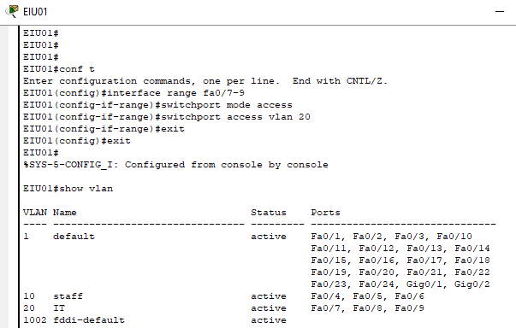

**EIU02**

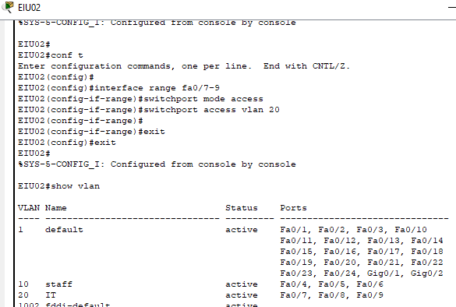

1. Can PC11 ping PC12? Why? **Answer:**

Yes, because it’s in the same switch.

2. Can PC11 ping PC13? Why? **Answer:**

No, we have to turn on the trunk gate.

**Step 6 : Create trunk port with Encapsulation dot1q**

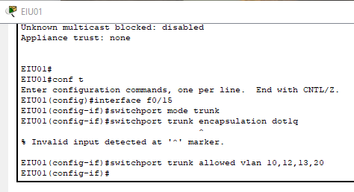

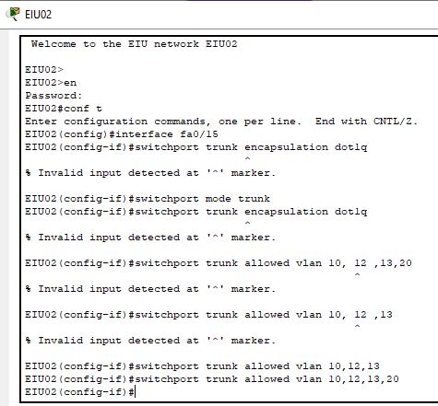

**Step 7: Check information on the Trunk interface with the following commands:**

**#show interface fastethernet 0/15 switchport**

**#show interface fastethernet 0/15**

**#show running-config**

**#show vlan**

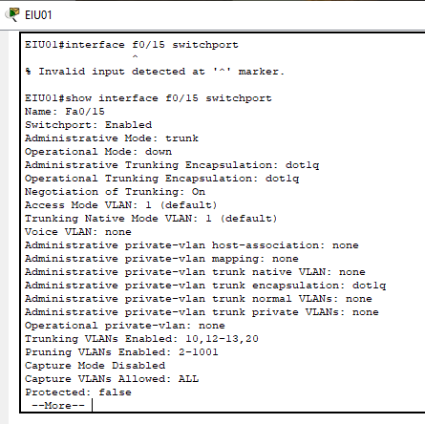

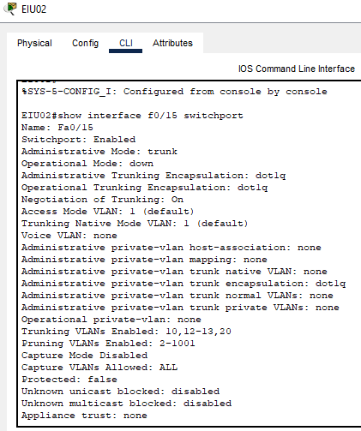

**Step 8: Check the connection between PCs**

1. Can PC11 ping PC13? Why?

Yes, because it’s in the same Vlan 10 and we have turn on trunk gate.



2. Can PC11 ping PC24? Why?

No, because it’s in a different Vlan: PC11 in Vlan 10 and PC24 in Vlan 20.



3. If **the PING was failed, suggest a solution to PING successfully**.

Option 1: Use a router to connect the router to the switches and configure sub-interfaces for each VLAN.

Option 2: Use a Layer 3 switch to configure SVI for VLAN 10 and VLAN 20 on the Layer 3 switch to route between VLANs.

Remember   
